Attentiveness of groups I (Session 9) | November 15th, 2009

Re-orientation:
We've covered a large body of ideas. Let us look at the big picture and see where our series has progressed.

Sharing "homework" results
What topic(s) will you be studying the next 9 months? What's your plan in studying this?

Review of session 1-8's concepts:
Thus far we've covered personal attentiveness and defined attentiveness in general. [Attentiveness defined: Sustained, recurrent, and present awareness of the totality of an object of intense interest or priority.
What it is: focusing of the mind on whatever is true and good.
What it is not: merely letting go of distractions to the point of emptying of self (Eastern religion's "mindfulness")] We've applied this concept in a variety of personal disciplines both as a basis and as a result.

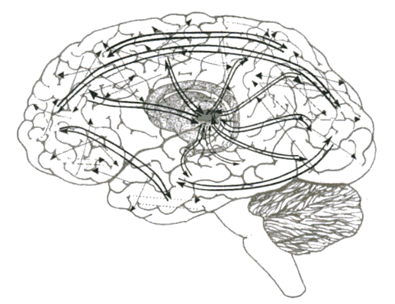
[Ref. 2] Illustration of reentrant model of attentiveness.

Attentiveness at a metaphor for group interactions:
Similar to the idea that "neurons that fire together wire together", individuals bond together that interact together. E.g. ref. 1
Analogies of function and dysfunction give us insights.

Discipline of confession beyond the personal realm
Evangelicals in rejecting the corrupt confessional system of the Catholics threw out the baby with the bath water.

Discipline of guidance
My own spiritual growth has benefited the most from my discipling relationships.

Discussion Questions for study:
- What characteristics are necessary in a person who receives confession?

- What characteristics are necessary in a person who gives guidance?

- What hinders us from confessing to another person?

For further thought/study:

- Easy: Identify a brother or sister who has the capacity to receive confession or the wisdom to give guidance (according to the characteristics you wrote down for discussion question 1 & 2).
- Moderate: Journal about all the things from which you've yet to receive complete freedom in your spiritual walk. Resolve to confess them to a trusted individual, and receive complete freedom from them.
- Advanced: Start a discipling relationship with someone younger than you, and receive the same from someone older than you.

Suggested readings and references:
1. Importance of Family Dinner V, Sept 2009 National Center on Addiction and Substance Abuse
2. Edelman, Gerald; Second Nature, 2006 Yale University Press
3. Crossman, Meg (Ed.); PathWays to Global Understanding, 2007 YWAM Publishing

Confession | Guidance
For the following passages please answer these questions:  1. Where does our authority to forgive come from?  2. Why is this a seldom practiced discipline in evangelical churches? Is this state appropriate?  3. What is the appropriate attitude in receiving confession from others?  James 5:16  John 20:21-23  Heb 10:24-25  1 Peter 2:9 | For the following passages please answer these questions:  1. Why is discipleship such an effective means to grow our spiritual lives?  2. Corporate guidance occur in many circumstances; identify the circumstances of each passage.  3. Share any experiences of guidance that are similar to these passages.  Titus 2:1-8  Acts 13:1-3  Matt 18:15-20, esp. 20; Matt 28:19a (what truly fulfills the great commission?)  Proverbs 27:17

"The research shows clearly how important it is to get to the dinner table with your kids. And it is also important for parents to give kids their undivided attention--and to get theirs." —Ref. 1, pg ii.
Confession
James 5:16
¹⁶Therefore, confess your sins to one another and pray for one another, that you may be healed. The prayer of a righteous person has great power as it is working.^{[a]}
John 20:21-23
²¹Jesus said to them again, "Peace be with you. As the Father has sent me, even so I am sending you." ²²And when he had said this, he breathed on them and said to them, "Receive the Holy Spirit. ²³ If you forgive the sins of any, they are forgiven them; if you withhold forgiveness from any, it is withheld.

Hebrews 10:24-25
²⁴And let us consider how to stir up one another to love and good works, ²⁵ not neglecting to meet together, as is the habit of some, but encouraging one another, and all the more as you see the Day drawing near.

1 Peter 2:9
⁹But you are a chosen race, a royal priesthood, a holy nation, a people for his own possession, that you may proclaim the excellencies of him who called you out of darkness into his marvelous light.
Guidance
Titus 2:1-8
¹But as for you, teach what accords with sound^{[a]} doctrine. ²Older men are to be sober-minded, dignified, self-controlled, sound in faith, in love, and in steadfastness. ³ Older women likewise are to be reverent in behavior, not slanderers or slaves to much wine. They are to teach what is good, ⁴and so train the young women to love their husbands and children, ⁵to be self-controlled, pure, working at home, kind, and submissive to their own husbands, that the word of God may not be reviled. ⁶Likewise, urge the younger men to be self-controlled. ⁷Show yourself in all respects to be a model of good works, and in your teaching show integrity, dignity, ⁸and sound speech that cannot be condemned, so that an opponent may be put to shame, having nothing evil to say about us.
Acts 13:1-3
¹Now there were in the church at Antioch prophets and teachers, Barnabas, Simeon who was called Niger,^{[a]} Lucius of Cyrene, Manaen a member of the court of Herod the tetrarch, and Saul. ²While they were worshiping the Lord and fasting, the Holy Spirit said, "Set apart for me Barnabas and Saul for the work to which I have called them." ³Then after fasting and praying they laid their hands on them and sent them off.
Matthew 18:15-20
¹⁵ "If your brother sins against you, go and tell him his fault, between you and him alone. If he listens to you, you have gained your brother. ¹⁶But if he does not listen, take one or two others along with you, that every charge may be established by the evidence of two or three witnesses. ¹⁷If he refuses to listen to them, tell it to the church. And if he refuses to listen even to the church, let him be to you as a Gentile and a tax collector. ¹⁸Truly, I say to you, whatever you bind on earth shall be bound in heaven, and whatever you loose on earth shall be loosed^{[a]} in heaven. ¹⁹Again I say to you, if two of you agree on earth about anything they ask, it will be done for them by my Father in heaven. ²⁰For where two or three are gathered in my name, there am I among them."
Matthew 28:19
¹⁹ Go therefore and make disciples of all nations, baptizing them in^{[a]} the name of the Father and of the Son and of the Holy Spirit,
Prov 27¹⁷Iron sharpens iron,
and one man sharpens another

