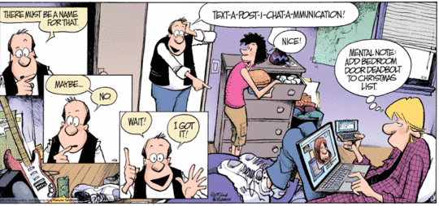

Current state of affairs:
Current state of affairs tears us away from paying attention, and saps our effectiveness for the kingdom of God.

How people spend their time
Large proportion of awake time is taken us with eating, working, and media consumption. Note in NY Times diagram^{[1]} that only ~2% of the time is spent "thinking".

The growth of media
Media content is growing as a geometric progression, global availability is over 15 Tbps^{[2]}, our consumption has steadily grown from.<10hr/wk in 1910s to >60hr/wk.

The imperative to multitask
At current projections the number of media-hrs consumed will be greater than the number of our wakeful hours. Many now multitask between multiple modes. Median page view is 12s.

The downfall of multitasking
Multitaskers are "suckers for irrelevancy", "they couldn't help thinking about the task they weren't doing. they can't keep things separate in their minds", they have poorer memory. ^{[3]}

[1] http://www.nytimes.com/interactive/2009/07/31/business/20080801-metrics-graphic.html
[2] TeleGeography Research
[3] Cognitive control in media multitaskers PNAS 2009 : 0903620106v1-pnas.0903620106

Pragmatic reason for our study:
Sustained attentiveness is necessary for personal effectiveness (Gal 1:17-18; 1 Tim 4:13 devote yourself ), and in a larger perspective, necessary for the body to complete long term objectives. (Book of Nehemiah: building the wall; anti-examples: Neh 8-9 didn't know what the law commanded)

Fundamental reason for our study:
Primary: Attentiveness is an attribute of God (Luke 12:6, 7, 22ff; Eph 1:3ff "insight"; 2 Chron 16:9 for the blameless; Amos 9:8 against the evil); we're called to imitate God. (Eph 5:1; Gen 1:26; 1 Cor 2:16)
Secondary: We're commanded to take every thought captive. (2 Cor 10:5)

Overview of this series: other page

Discussion Questions:
- In view of what we observe about average awake time budget, what are some surprises? What do you identify with the most?
- How do you feel your effectiveness as a member of the kingdom of God is affected by your level of attentiveness?
- Do you multitask and how is that choice working for you?

For further thought/study:

- Closely observe a multitasking session. Note the speed of decision, the ease of switching between tasks, and ability to filter for salient cues. Would this have been better done differently? How?
- During this week's devotion time ask God to open your eyes to aspects of your life where greater attentiveness is needed.
- During this week's devotion time, read the scriptures with an eye for the concepts of attentiveness.

